3
SWT 22022 – Practical for  Internet Application  Development | 30.09.2024

Department of Information and Communication Technology
Faculty of Technology
Lab sheet :13
Reg. Number: SEU/IS/20/ICT/084
Academic Year :2020/2021
Date: 2024.10.07
Practical No :12

Title: Version Control with GitHub

Aims:
- Setting up development environment
- Create repository
- Link changes to the repository
Tasks:
  - Install Git on Windows
  - Configure Git
  - Create a GitHub Account
  - Create a Local Repository
  - Stage and Commit Changes
  - Create a Remote Repository on GitHub
  - Link Local Repository to GitHub
  - Push Changes to GitHub
  - Creating and Using Branches
  - Pull Changes to GitHub
  - Collaborating with GitHub
Activities :
- Install Git on Windows
  - Download Git for Windows.
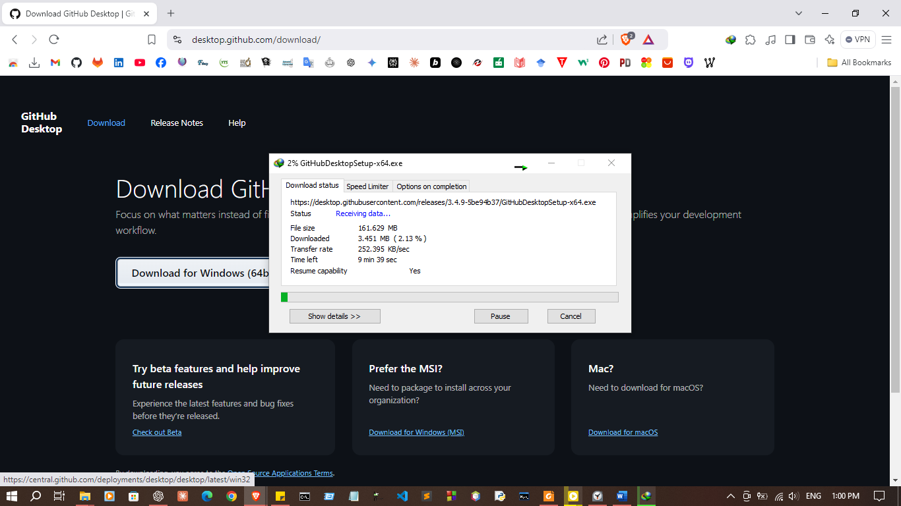

  - Install Git and use the default settings.

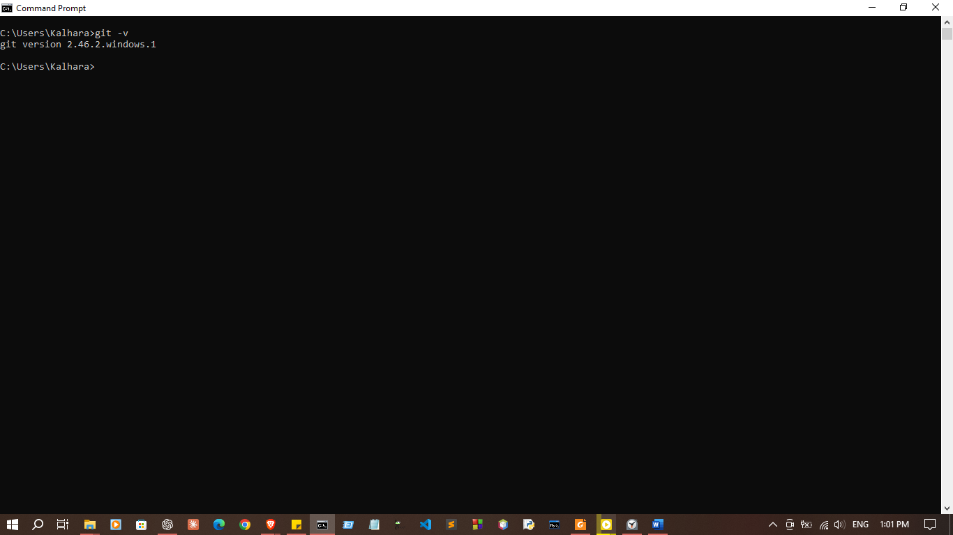
  - Verify the setup by running the following in the CMD o git --version

- Create a GitHub Account
  - Go to GitHub and Create an account
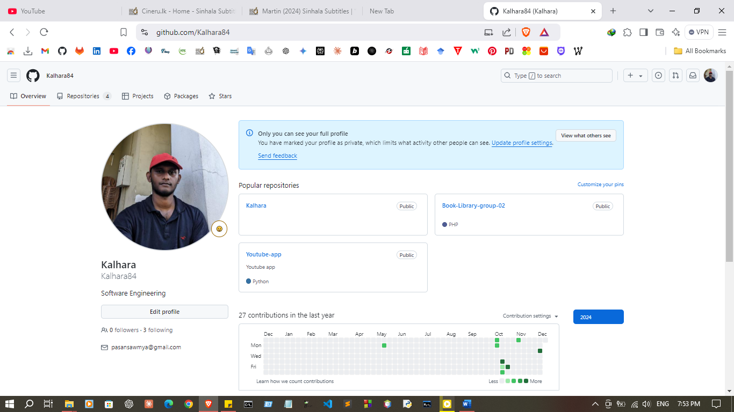
- Configure Git
  - Set up username and email for commits
  - git config –global user.name “Your name”
  - git config –global user.email “email@example.com”
  - Verify the configuration o git config --list
git config --global user.name Kalhara
git config --global user.email pasansawmya@gmail.com
git config –list
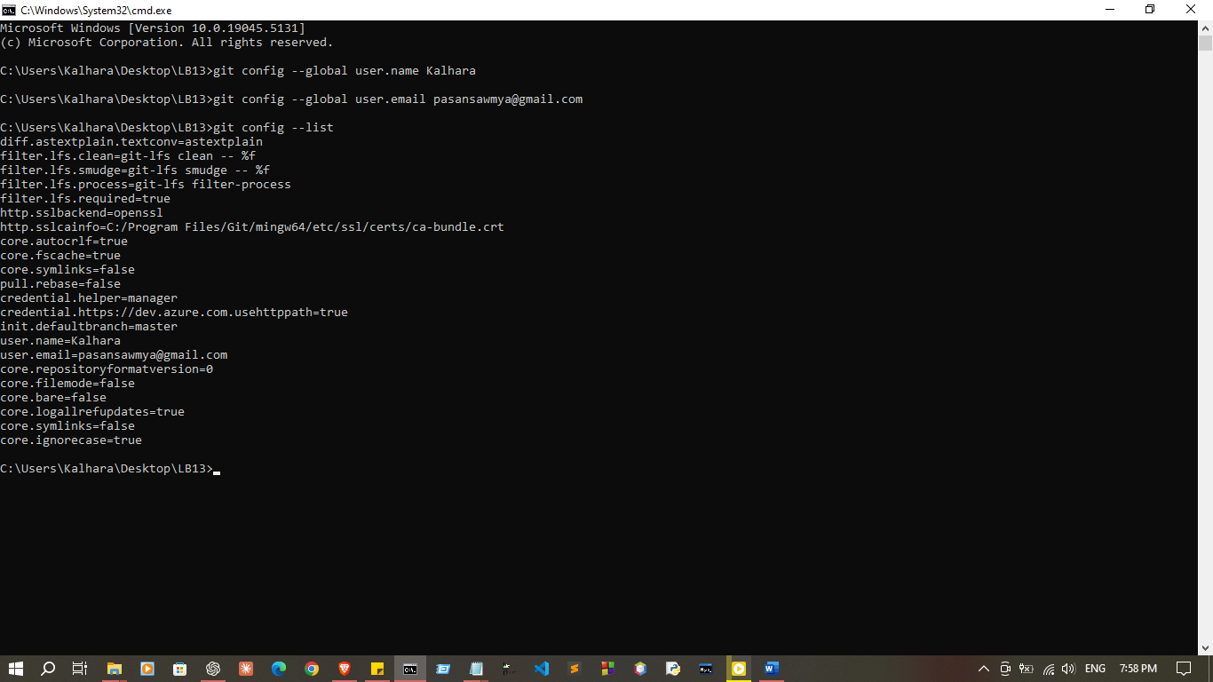

- Create a Remote Repository on GitHub
  - Log into GitHub and create a new repository
- Create a Local Repository
  - Open command prompt
  - Navigate to your project directory
  - Initialize a new Git repository

git init
git remote add origin https://github.com/Kalhara84/LB13.git

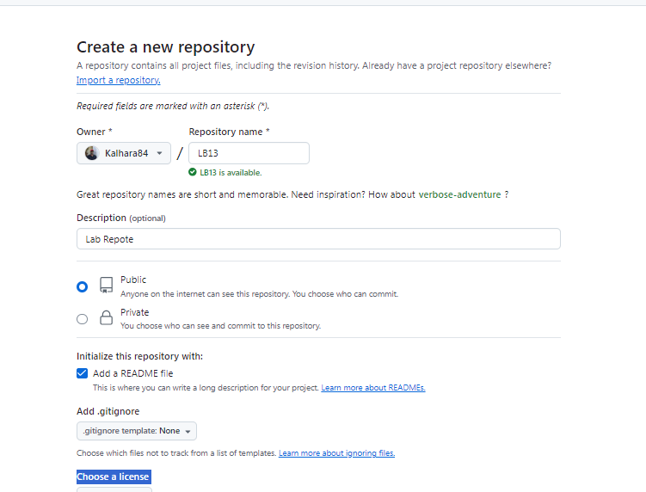
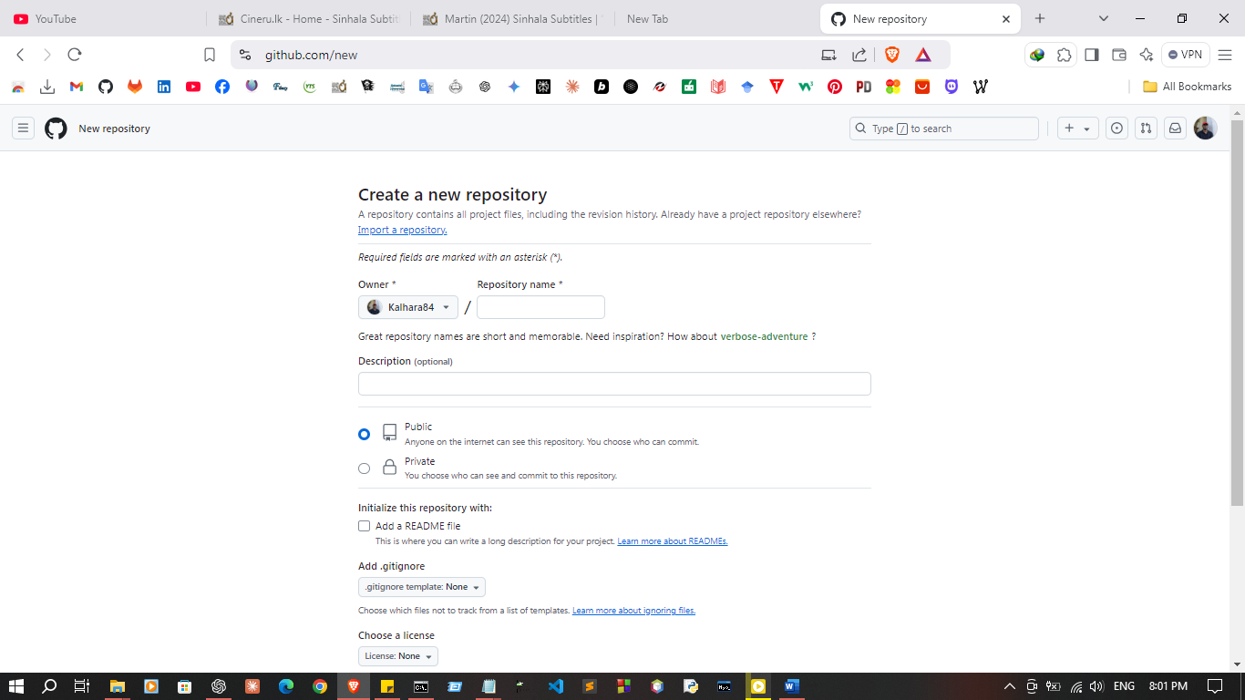

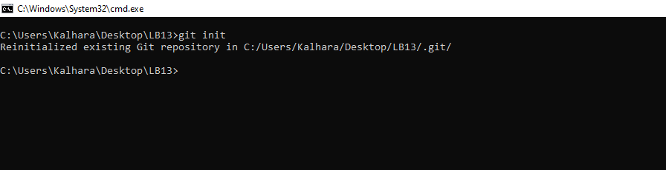
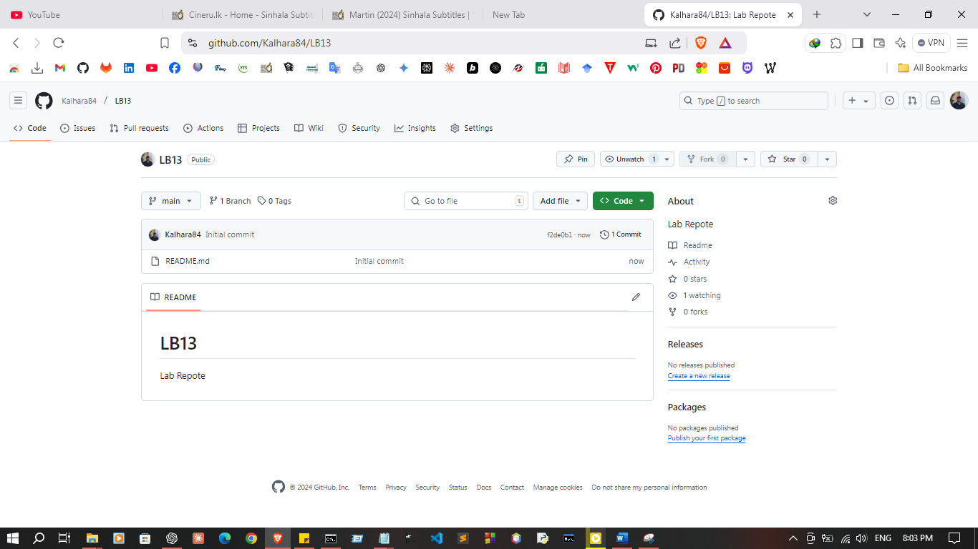
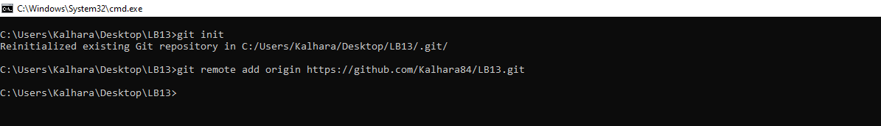

- Stage and Commit Changes
  - Add files to the staging area
    - git add . (for all files)
o git add file_name.txt (for one file)
  - Commit the changes
o Git commit -m “Initial Commit”
# Verify Git installation
git --version
# Configure Git
git config --global user.name Kalhara
git config --global user.email pasansawmya@gmail.com
git config --list
# Initialize a local repository
git init
# Add files to the staging area
git add . # Add all files
git add text.html # Add a specific file
# Commit changes
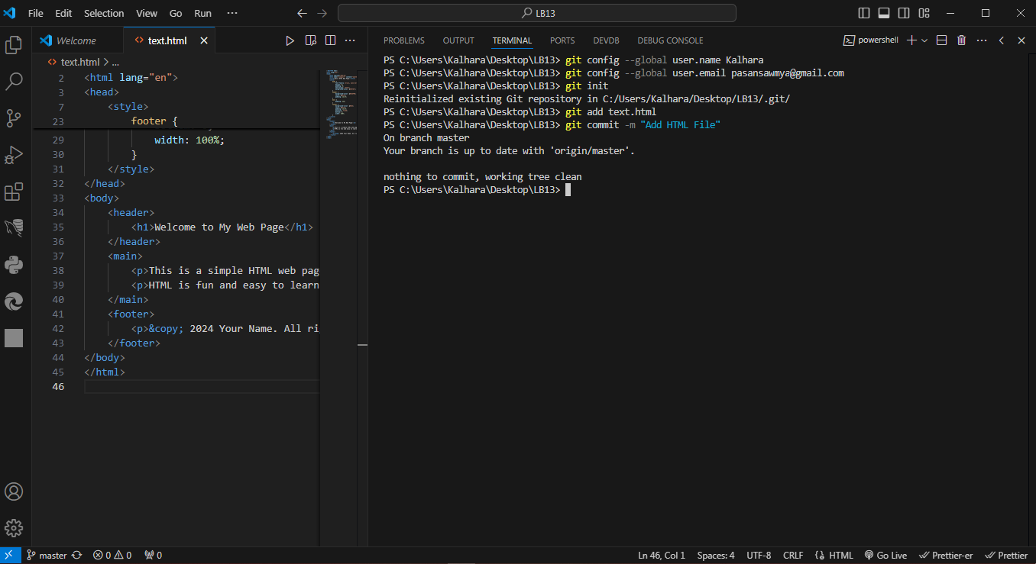
git commit -m "Add HTML File"

- Link Local Repository to GitHub
  - Copy the repository URL
  - Add the remote repository URL
o git remote add origin paste_url
git remote add origin https://github.com/Kalhara84/LB13.git
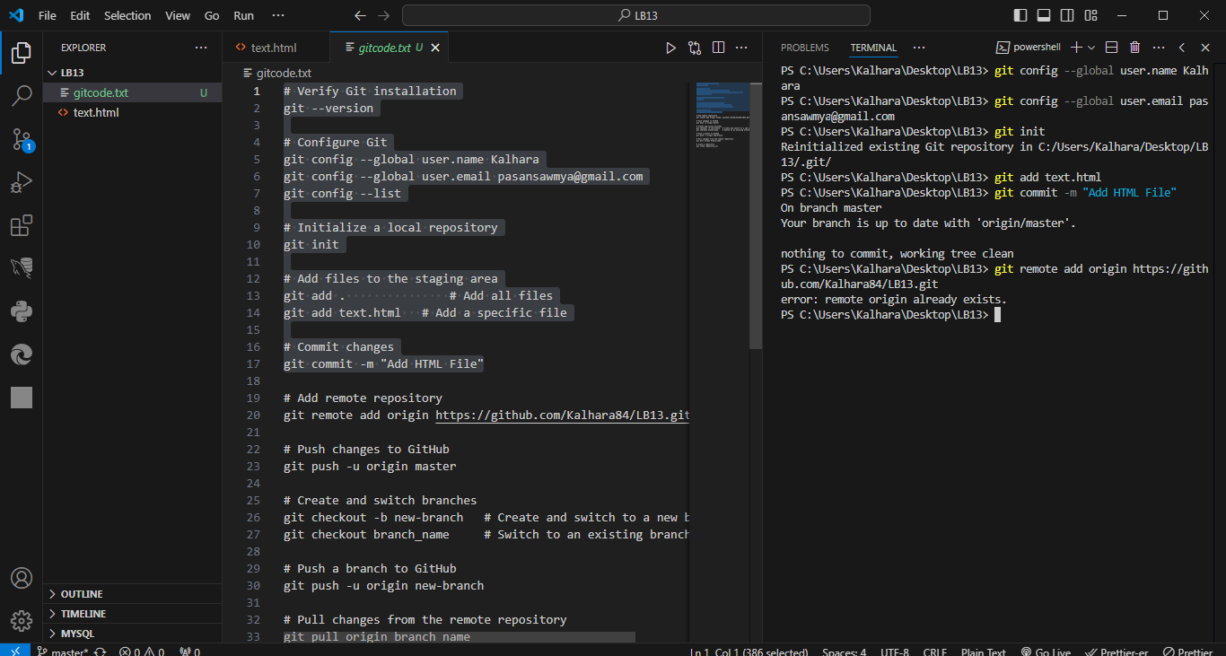
- Push Changes to GitHub
  - Push your commits to GitHub
o git push -u origin master
# Push changes to GitHub
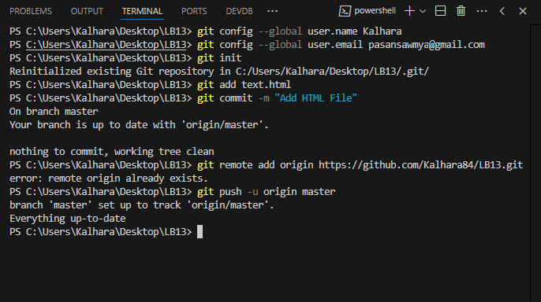
git push -u origin master

- Creating and Using Branches
  - Create a new branch
o git checkout -b new-branch
  - Switch to the branch
o git checkout new-branch
  - Push the branch to GitHub
# Create and switch branches
git checkout -b Branche_01 # Create and switch to a new branch
git checkout Branche_01 # Switch to an existing branch
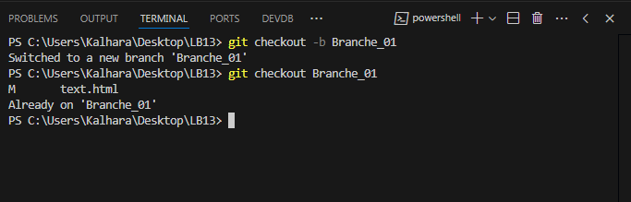

# Push a branch to GitHub
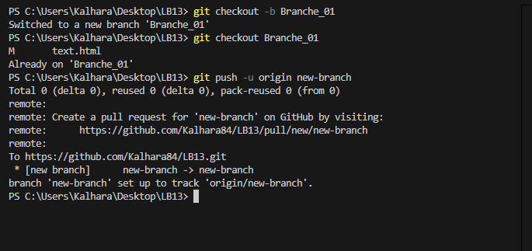
git push -u origin new-branch
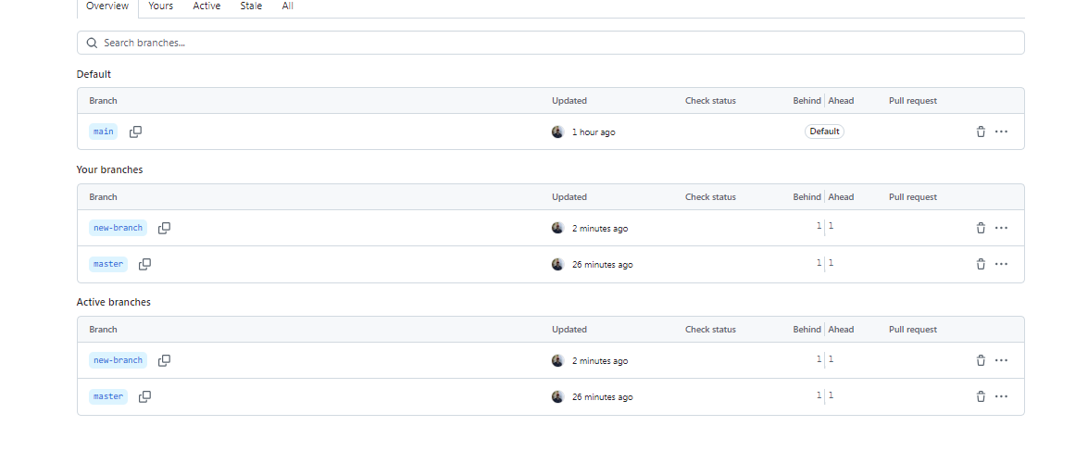

- Pull Changes from GitHub
  - To fetch and merge changes from the remote repository
# Push a branch to GitHub
git push -u origin Branche_01
# Pull changes from the remote repository
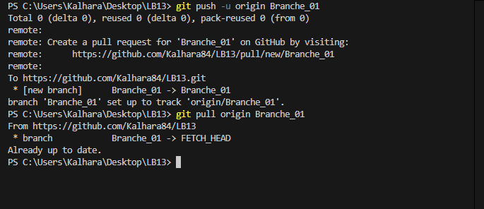
git pull origin Branche_01

- Collaborating with GitHub
  - Clone the repository
    - Git clone repository_url
# Clone a repository
git clone https://github.com/Kalhara84/LB13.git
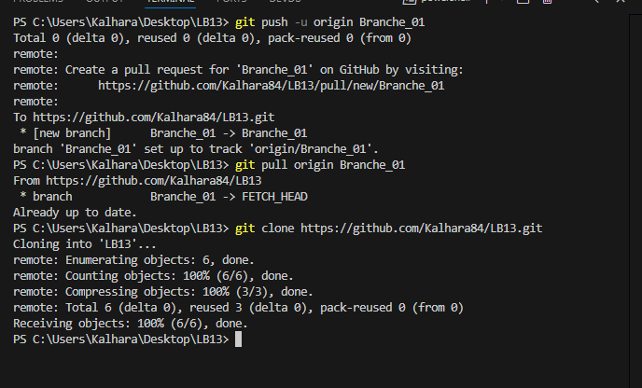

Discussion:
- Version control with GitHub is an essential skill for managing code efficiently in a collaborative environment. In this lab practical, we learned to set up a development environment by installing and configuring Git on Windows. We started by creating a GitHub account and setting up a local repository to track changes. After staging and committing code, we established a connection between the local repository and a remote repository on GitHub. This allowed us to push changes online, ensuring our work was securely backed up and accessible to collaborators. We explored branch creation and usage for managing separate features or fixes, and practiced pulling changes to stay updated with others' work. The session highlighted the importance of collaboration by learning how to manage contributions from multiple users effectively on GitHub. This hands-on approach provided a comprehensive understanding of version control in a real-world development workflow.

